## Architecting with Components

**Learning Objectives**

• Know how to *architect* an angular Application.

**Process**

When building a new Angular application, we start by:

1. Breaking down an applications into seperate Components.
2. For each component we describe it’s *resonsibilities*.
3. Once we’ve desribed the responsibilites we then describe it’s *inputs & outputs*, it’s public facing interface.

Take for instance this simple example.

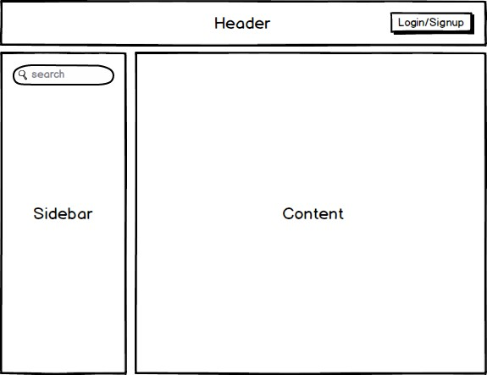

We have a basic application with a Header, Sidebar and Content area, we would implement each of these as their own Component. The next stage is for each component to list out the responsibilities, inputs and outputs, like so:

**HeaderComponent**

**Responsibilities**

All aspects of authentication. Letting the user login/signup and logout.

**Inputs**

None

**Outputs**

* + LoginChanged - An output event that is fired when the users login state changes.

**SidebarComponent**

**Responsibilities**

Performing searches

**Inputs**

None

**Outputs**

* + SearchTermChanged - An output event that is fired when a user performs a search, $event contains the search term.

**ContentComponent**

**Responsibilities**

Showing the search results.

**Inputs**

* + SearchTerm the search term that we want to filter the results by.

**Outputs** None

Listing the inputs and outputs and what area this Component is responsible for

helps to ensure the Components are architected correctly. The goal is for each Component to have a well defined *boundary*.

**Data Flow**

When we link up the Components above with our applications root Component the flow of data between all the inputs and outputs might look something like this:

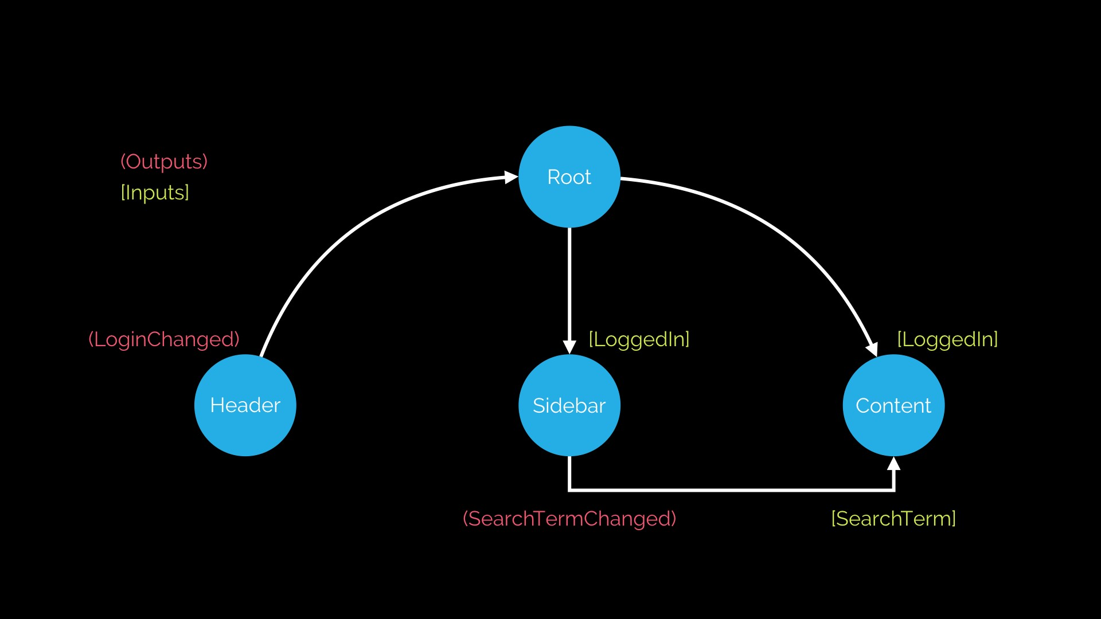

The actual binding of inputs and outputs happens in HTML, in the templates of Components. The template for our root Component might end up looking like so:

<header (loginChanged)="loggedIn = $event"></header>

<sidebar (searchTermChanged)="searchTerm = $event"></sidebar>

<content [searchTerm]="searchTerm"></content>

Data flow describes how we **glue** Components together through their inputs and outputs.

Closely looking at the diagram above an interesting fact occurs; with one way data binding, *inputs go down* the tree, *outputs go up* the tree. With one way data binding reasoning about your application becomes a lot simpler, we can trace through the flow of events in our application easily.

**Summary**

Architecting an Angular application means understanding that it’s just a tree of Components, each Component has some inputs and outputs and should have a clear responsibility with respect to the rest of the application.

Components are *composable*, so we might go a step further and include a LoginButtonComponent in our HeaderComponent. But only if we would want to re-use the LoginButtonComponent independently of the HeaderComponent.